- TEST SPECIFICATION
Job Number | TFS-EMC202506-060
EUT Name | Hot Plate and Stirrer
EUT Model/SKU Number | SP88857198-EVAL1
EUT Serial Number | M3719810042592886
Basic Standard | EN 61000-4-11:2020 & IEC 61000-4-11:2020
Product Standard | IEC 61326-1:2020, EN 61326-1:2021
Immunity test requirement | ☒ Basic ☐ Industrial ☐ Controlled ☐ Custom
Test Port | ☒ Power Line
Test Level | Voltage Dips |  |  |  | Interruption
 | 0 % | 0 % | 70% |  | 0 %
 | 0.5 cycle | 1 cycle | 25/30cycle |  | 250/300cycle
Number of Voltage Dips/Interruptions | ☒ 3 times ☐ Custom______
Time between Dips/Interruptions | ☒ 60 sec ☐ Custom______
Phase Angle | 0° to 360° with 45° step
Test Mode | Mode A
EUT Configuration | ☒ Tabletop |  |  | ☐ Floor standing
EUT Input Voltage & Frequency | 230 VAC 50/60Hz
Ambient Temperature (°C) | 26.6
Relative Humidity (%) | 64.7
Test Date | 02.07.2025
Tested by | Md Abubakar Siddeeq
- EQUIPMENTS USED
S. No | Equipment Name | Make | Model No. | Serial No. | Cal Due Date
1 | Compact NX Generator | AMETEK CTS | compact NX5  bspt-1-300-16 | P2237267200 | 11.03.2026
2 | Motorized Variac | AMETEK CTS | variac NX1-260-16 | P2231266368 | 12.03.2026

- EUT MODIFICATION RECORD
The table below details the modifications made to the EUT during the test program.
Modification state | Description of Modification still fitted to EUT | Modification fitted by | Date modification fitted
0 | Initial state

- FUNCTIONAL CHECK:
Functional check is conducted as per SOP reference number: IEC-SOP-502.and observed no deviation.

- MONITORING PARAMETERS:
- RPM & Temperature needs to be monitored in the LCD display
- Temperature: 60 ±5° C
- RPM:1500 ±2%

- TEST OBSERVATION
Voltage Dips:230VAC 50Hz
Test Level % Ut | Duration (cycles/periods) | Observation
0 | 0.5 | B1
0 | 1 | B2
70 | 25 | B3

Interruptions:
Test Level % Ut | Duration (cycles/periods) | Observation
0 | 250 | B6

Voltage Dips:230VAC 60Hz
Test Level % Ut | Duration (cycles/periods) | Observation
0 | 0.5 | B4
0 | 1 | A
70 | 30 | B5

Interruptions:
Test Level % Ut | Duration (cycles/periods) | Observation
0 | 300 | B6
NOTE 1:
A: No degradation was observed during the test based on the parameters monitored.
B1: The Rpm speed changed to 1500 -1445 while performing the testing but temp within limits
B2 The Rpm speed changed to 1500 -1386 while performing the testing but temp within limits

B3 The Rpm speed changed to 1500 -1257 while performing the testing but temp within limits

B4: The Rpm speed changed to 1500 -1471 while performing the testing but temp within limits
B5: The Rpm speed changed to 1500 -1341 while performing the testing but temp within limits
B6: EUT Display has turned off and again it has recovered back, and manual interruption required to operate the unit.

- TEST SETUP PICTURES
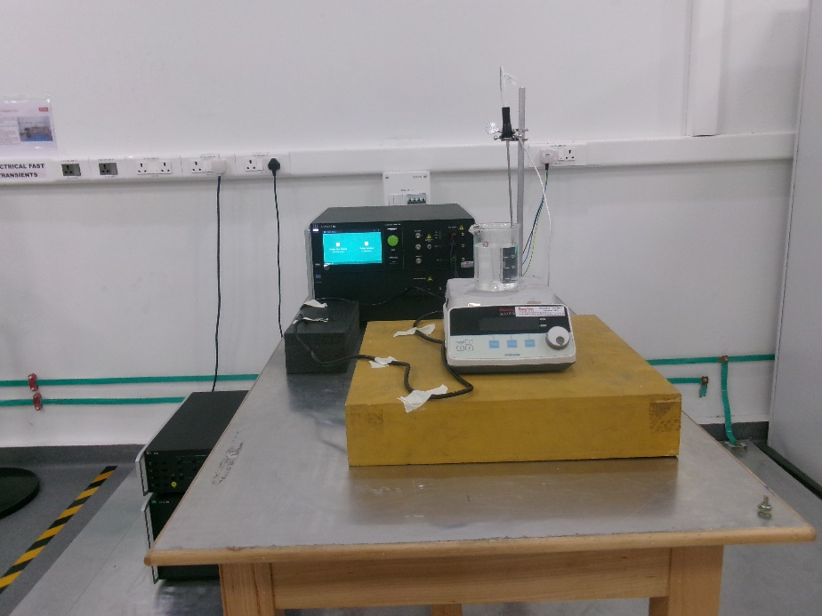
Figure 1: Photograph of Voltage Dips and short Interruptions test setup
- REFERENCE FOLDER:
Product Test Lab/Product Testing/Projects/2025/TFS-EMC-202506-060/Test Data/VDIPS

- SOFTWARE DETAILS:
Software Used | Software Version
iec.control | 10.3.2

- RESULT:
Required Performance Criteria | Voltage Dips |  |  | Interruption
 | 0 % | 0% | 70% | 0 %
 | B | B | C | C
Met Performance Criteria (230 VAC 50Hz) | B1 | B2 | B3 | B6
Met Performance Criteria (230 VAC 60Hz) | B4 | A | B5 | B6

Tested By
Name | Md Abubakar Siddeeq
Signature | 
Date | 02.07.2025

